**Curtain Track Requirement Form**

**Track Shape**

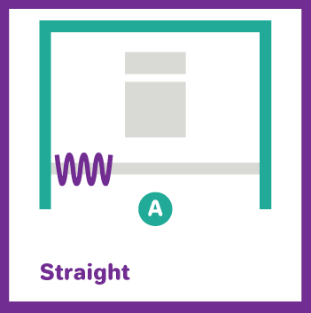 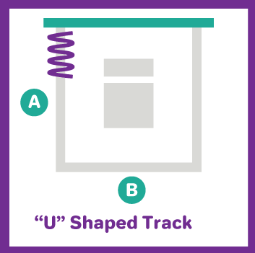 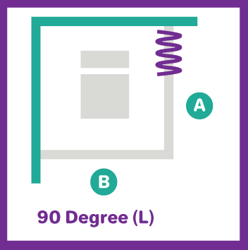 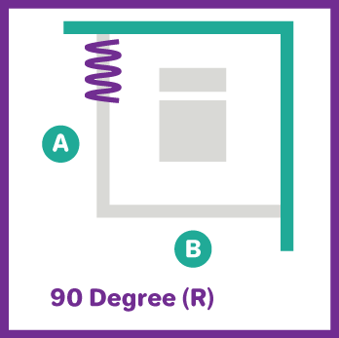

**Track Dimensions (in CM)**

|  |  |  |  |  |  |  |  |
| --- | --- | --- | --- | --- | --- | --- | --- |
| **Track 1** | | **Track 2** | | **Track 3** | | **Track 4** | |
| **Shape:** | | **Shape:** | | **Shape:** | | **Shape:** | |
| **A** |  | **A** |  | **A** |  | **A** |  |
| **B** |  | **B** |  | **B** |  | **B** |  |

**Track Style (Tick as Appropriate)**

|  |  |  |  |  |  |  |  |
| --- | --- | --- | --- | --- | --- | --- | --- |
| **Track 1** | | **Track 2** | | **Track 3** | | **Track 4** | |
|  | **Movatrack**  (Compatible with Universal curtains) |  | **Movatrack**  (Compatible with Universal curtains) |  | **Movatrack**  (Compatible with Universal curtains) |  | **Movatrack**  (Compatible with Universal curtains) |
|  | **Omnitrack**  (Compatible with Fast-Fit, Universal and Uni-Glide curtains) |  | **Omnitrack**  (Compatible with Fast-Fit, Universal and Uni-Glide curtains) |  | **Omnitrack**  (Compatible with Fast-Fit, Universal and Uni-Glide curtains) |  | **Omnitrack**  (Compatible with Fast-Fit, Universal and Uni-Glide curtains) |
|  | **Clinitrack**  (Compatible with Fast-Fit and Universal curtains) |  | **Clinitrack**  (Compatible with Fast-Fit and Universal curtains) |  | **Clinitrack**  (Compatible with Fast-Fit and Universal curtains) |  | **Clinitrack**  (Compatible with Fast-Fit and Universal curtains) |

**Wall Fixings Requirements (Tick as Appropriate)**

|  |  |  |  |  |  |  |  |
| --- | --- | --- | --- | --- | --- | --- | --- |
| **Track 1** | | **Track 2** | | **Track 3** | | **Track 4** | |
|  | Both ends of tracks to be fixed to the wall |  | Both ends of tracks to be fixed to the wall |  | Both ends of tracks to be fixed to the wall |  | Both ends of tracks to be fixed to the wall |
|  | Only one end of the track to be fixed to the walls |  | Only one end of the track to be fixed to the walls |  | Only one end of the track to be fixed to the walls |  | Only one end of the track to be fixed to the walls |
|  | Neither end of the track to be fixed to walls |  | Neither end of the track to be fixed to walls |  | Neither end of the track to be fixed to walls |  | Neither end of the track to be fixed to walls |
|  | Ceiling Support |  | Ceiling Support |  | Ceiling Support |  | Ceiling Support |

**Curtain Gliders (Tick if Required)**

|  |  |  |  |
| --- | --- | --- | --- |
| **Track 1** | **Track 2** | **Track 3** | **Track 4** |
|  |  |  |  |

**Quantities (Number of each track required)**

|  |  |  |  |
| --- | --- | --- | --- |
| **Track 1** | **Track 2** | **Track 3** | **Track 4** |
|  |  |  |  |

**Delivery Address:**

**Additional information for ceiling support:**

**Please use the below detail to help decide which ceiling support is required.**

